1. Add your domain details in [**mailgun**](https://app.mailgun.com/mg/sending/new-domain)
2. Enter your SPF, CNAME , MX , DKIM , DMARC values in your DNS provider
3. Follow the DNS configuration setup for your name space provider check in this[**link**](https://help.mailgun.com/hc/en-us/sections/360006038234-DNS)
4. Once u entered the values from the mailgun to your namespace provider , the example values will be shown as below (make sure to click the verify DNS settings button once u configured )

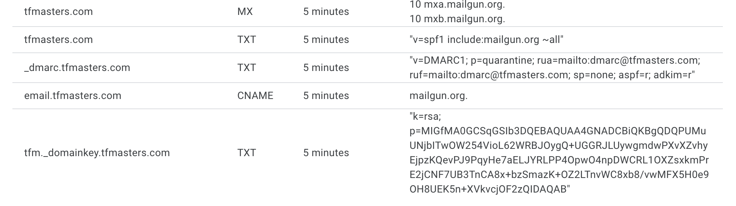

1. Follow the DMARC as mentioned in the above image or use the example as below either 1
   1. **"v=DMARC1; p=quarantine; rua=mailto:dmarc@mydomain.com; ruf=mailto:dmarc@mydomain.com; sp=none; aspf=r; adkim=r"**
   2. **"v=DMARC1; p=none; rua=mailto:dmarc@mydomain.com; ruf=mailto:dmarc@mydomain.com; sp=none; aspf=r; adkim=r"**
2. Once the entire configuration is done , double check your domain in this look up [**url**](https://mxtoolbox.com/)for verification .
3. Now you’re ready to rock and roll to send email , for example check [**here**](https://documentation.mailgun.com/docs/mailgun/api-reference/openapi-final/tag/Messages/#:~:text=the%20user%20manual.-,Send%20an%20email,-POST)